Lab 6

Group: 3

Section: 2

Names and IDs:

Joudy Zeyad Elsherbiny 9443
Malak Mokhtar Lotfy 9619
Rana Adel Abdelhady 9301
Farida Samir Youssef 9603

- Use Case Diagram

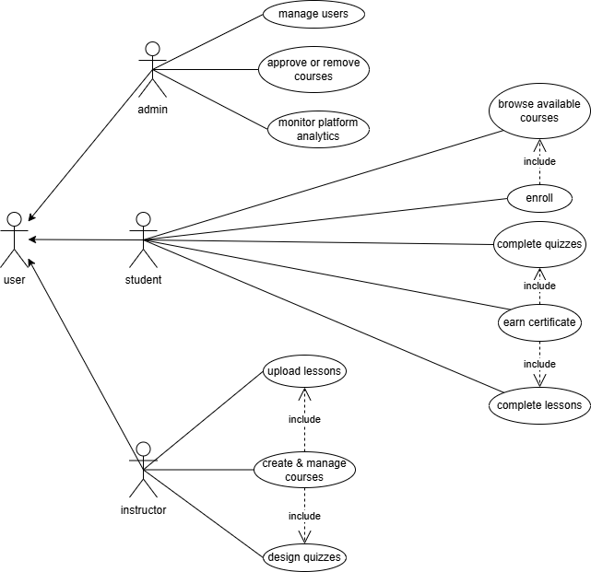

The Use Case Diagram represents the interaction between the SkillForge platform and its primary actors: Student, Instructor, and Admin, all inheriting from the general User actor. It defines each actor’s responsibilities, such as course enrollment, content creation, and system management. The diagram also incorporates include relationship to illustrate common and conditional behaviors within the system’s processes.

- Activity Diagram
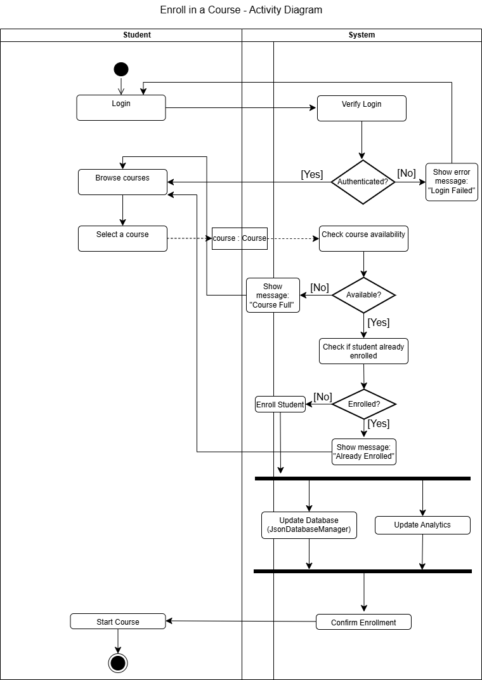
Activity diagram is a behavior diagram that shows the flow of actions or activities in a system. For example, this diagram represents the “Enroll in a Course” process in the SkillForge system, starting from the student logging in, browsing and selecting a course and how the system checks availability of the course and enrollment status of the student before enrolling the student to updating the JSON database and Analytics module in parallel then, confirming the enrollment. This diagram also shows the object flow which represents the data passed between activities like, course: Course and enrollment: EnrollmentRecord.
- Class Diagram
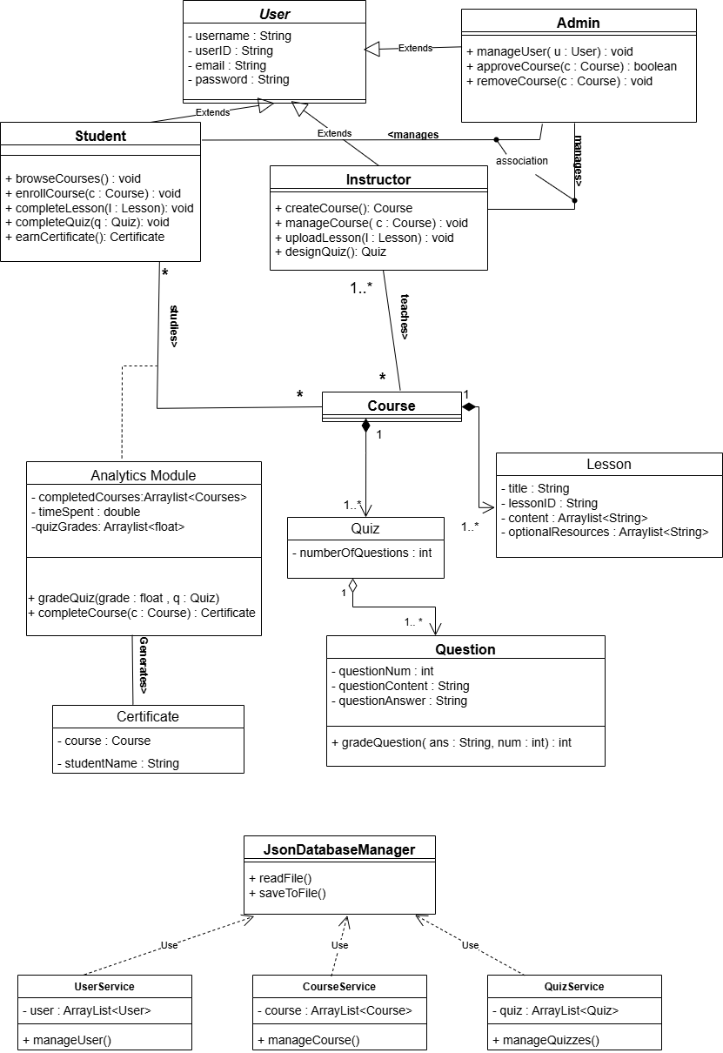
Class diagram is a structural diagram that shows the main classes and their relationship with each other. It is used to facilitate the implementation process by showing the coder where the OOP concepts can be implemented. For example: the diagram shows that we will have a parent class called user that will be inherited by 3 subclasses , 3 other classes depend on the database manager class and so on. So, the class diagram shows the coder how to make reusable parts of the code for easier implementation.
4)Sequence diagram
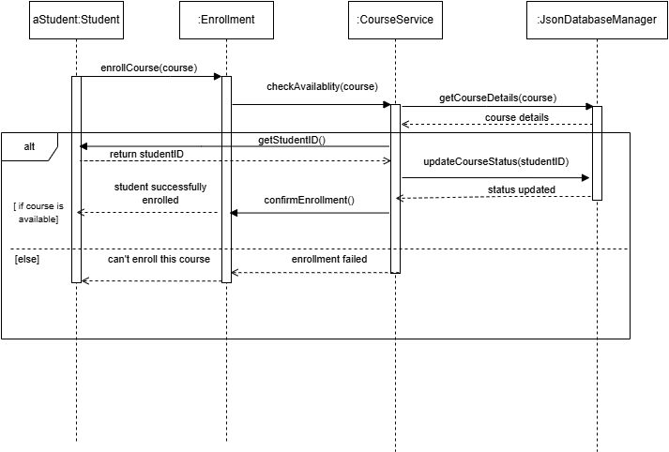

The sequence diagram shows the step-by-step message flow during course enrollment.
It represents how students, services, and the database interact in real time.
This helps visualize system behavior, ensuring clear communication and correct process design.

